Rain Prediction –Weather forecasting

Weather forecasting is the application of science and technology to predict the conditions of the atmosphere for a given location and time. Weather forecasts are made by collecting quantitative data about the current state of the atmosphere at a given place and using meteorology to project how the atmosphere will change.

About the dataset

Rain Dataset is to predict whether or not it will rain tomorrow. The Dataset contains about 10 years of daily weather observations of different locations in Australia.

Data pre-processing

The main target of this dataset can be used to predict the weather for the next day or week with huge amounts of data provided in the dataset. Furthermore, this data can also be used to make visualization which would help to understand the impact of global warming over the various aspects of the weather like precipitation, humidity, temperature, etc.

Historical Weather Dataset

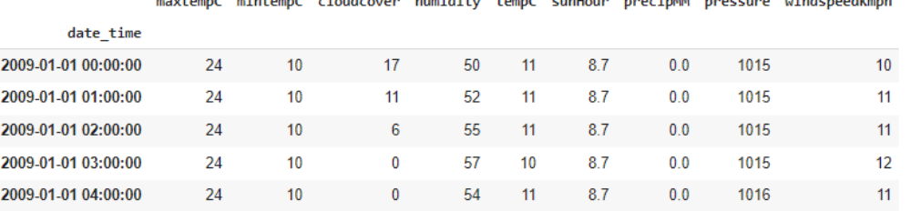

Machine Learning Model for Weather Forecasting
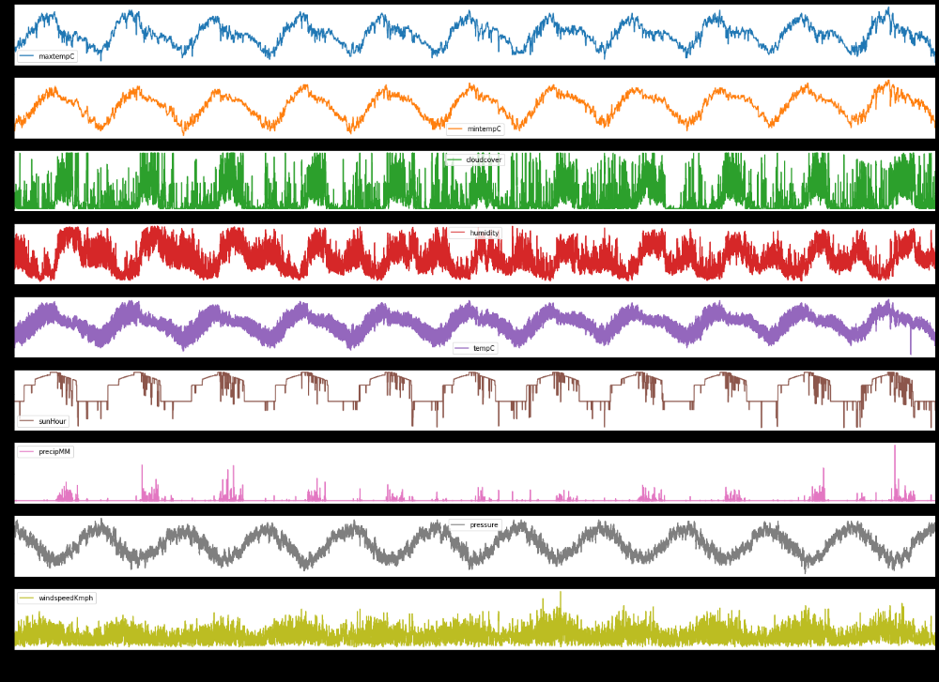

EXPERIMENTATION

The record has just been separated into a train set and a test set. Each information has just been labeled. First, we take the trainset organizer. We will train our model with the help of histograms and plots. The feature so extracted is stored in a histogram. This process is done for every data in the train set. Now we will build the model of our classifiers. The classifiers which we will take into account are Linear Regression, Decision Tree Regression With the help of our histogram, we will train our model. The most important thing in this process is to tune these parameters accordingly, such that we get the most accurate results. Once the training is complete, we will take the test set. Now for each data variable of the test set, we will extract the features using feature extraction techniques and then compare its values with the values present in the histogram formed by the train set. The output is then predicted for each test day. Now in order to calculate accuracy, we will compare the predicted value with the labeled value. The different metrics that we will use confusion matrix, R2 score, etc.
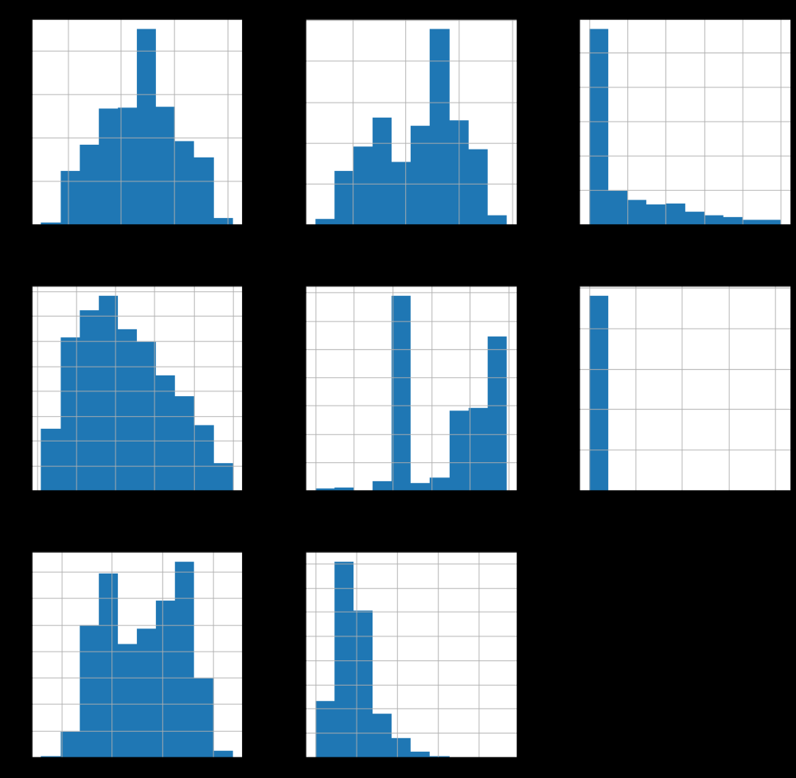

RESULT AND DISCUSSION

The results of the implementation of the project are demonstrated below.
Multiple Linear Regression:
This regression model has high mean absolute error, hence turned out to be the least accurate model. Given below is a snapshot of the actual result from the project implementation of multiple linear regression.
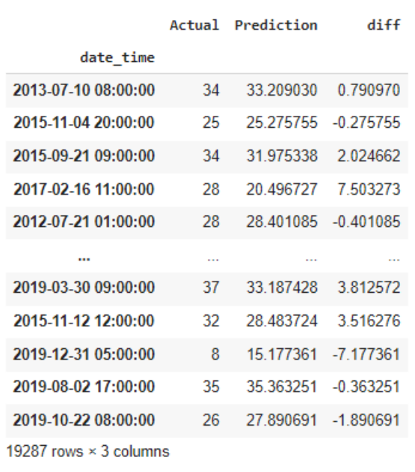
Decision Tree Regression:
This regression model has medium mean absolute error, hence turned out to be the little accurate model. Given below is a snapshot of the actual result from the project implementation of multiple linear regression.
